Paper Review of Cheng by 06/16/2020

* Title: Towards Urban 3D Reconstruction from Video
* Needs
  + Traditional model constructed by GPS provide little useful information for visualization
  + Due to the bad viewing angle, high-quality images cannot be given by GPS
* Objectives
  + Capture image data to make 3D model in real-time while driving
  + sparse reconstruction according to INS/GPS
  + Use sparse reconstruction results and video data to build 3D model of the urban scene.
* Methodology
  + This paper introduces a pipeline of image processing, including feature detection for 2D point correspondences, use INS/GPS to get real-time location of cameras and build a Euclidean space.

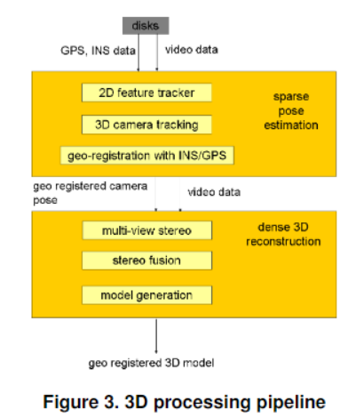

* + Using multiple methods to build Geo-Registration with INS/GPS data: geo-location measurements and tracking 2D features with Kalman filter or bundle adjustment.
  + Integrate video data (recorded by DVR) and information of location and direction(measured and evaluated by Applanix INS / GPS navigation system), and use OpenCV to correct wrong position information automatically.
* Results

Complete a reconstruction demo in each direction of the camera.

Figure 7-9 are not using INS/GPS information.

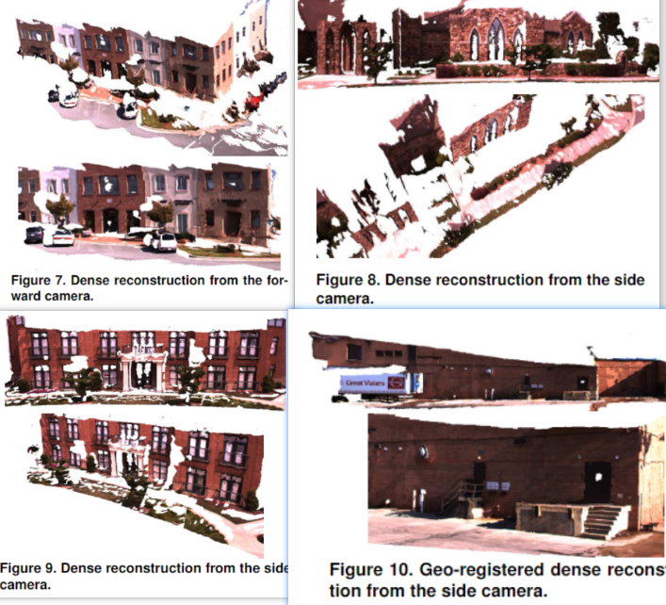

* Discussion
  + Future research will be focusing on reducing dependence on keeping point correspondence and feature detection.
* Conclusion
  + This paper describes a 3D city reconstruction system, using position and direction information which provided by INS/GPS, to make dense 3D model.
  + The authors designed a pipeline to make data processing and model construction, which allow multiple CPUs and GPUs operating at the same time, for real-time analysis and reconstruction.